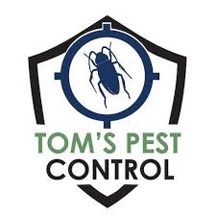
Tom’s Pest Control
1300 866 773
commercial@tomspestcontrol.com.au
www.tomspestcontrol.com.au

Site Specification - Chef Q
Tom’s Pest Control Pty Ltd
ABN: 27 640 970 734
Date: 03/07/2025

Frequency of Service: Every 3 months for Rodent Monitoring and Re-baiting and Replacement (if need be)

Pests Covered: Rodents

Type of Treatments: Installation of 25 x LBS Rodent Stations (toxic baits to be used externally and non-toxic baits to be used internally)

Areas Serviced: Rodent Stations (Internal and External).
Please refer to the site map for the locations of the stations.

Pesticides that will be used on this site: DETEX with Lumitrack baits (this will be used for all food handling areas rodent bait stations), Ditrac Soft Baits (will be used for all non-food handling areas) and Generation First Strike Soft Bait.

Clients' Food Safety Management Standards: Non-toxic baits to be used for rodents in food handling areas, as well as a clear site map with any stations internally, approved food handling area products to be used if separate treatments are to be done on-site.

